PHASE 7 – PROJECT DOCUMENTATION

7.1 Introduction
This phase consolidates the project information into a structured technical document.
PocketSmart AI is a web-based smart budget and recommendation assistant developed to process user requirements and generate suitable recommendations according to the submitted information and budget.

7.2 Project Purpose
The purpose of PocketSmart AI is to simplify budget-based decision making by providing an organized interface for entering requirements and receiving recommendations.

7.3 Major Features
The major implemented features include:
- User registration.
- User login.
- Dashboard.
- Budget input.
- Requirement collection.
- Recommendation generation.
- Recommendation result display.
- Recent plans/history.
- Database-backed data management.

7.4 Technologies Used
The project uses:
- Python
- FastAPI
- SQLite
- HTML
- CSS
- JavaScript/templates
- Visual Studio Code
- Web browser

7.5 System Architecture
The system consists of the frontend, FastAPI backend, recommendation processing, and SQLite database.
User
↓
Frontend (HTML/CSS/JavaScript)
↓
FastAPI Backend
↓
Authentication / Planner Modules
↓
Gemini AI Recommendation Module
↓
SQLite Database
↓
Recommendation Result → User

7.6 Project Workflow
The final workflow is:
User → Authentication → Dashboard → Budget & Requirements → Recommendation Processing → Results → History/Recent Plans
User Login/Register
↓
Dashboard
↓
Select Planner
↓
Enter Budget & Requirements
↓
Generate Recommendation
↓
AI Processes Input
↓
Recommendation Generated
↓
Save to Recent Plans / History
↓
User Views Result

7.7 User Interface
The application provides a simple web interface for users to interact with the recommendation system.
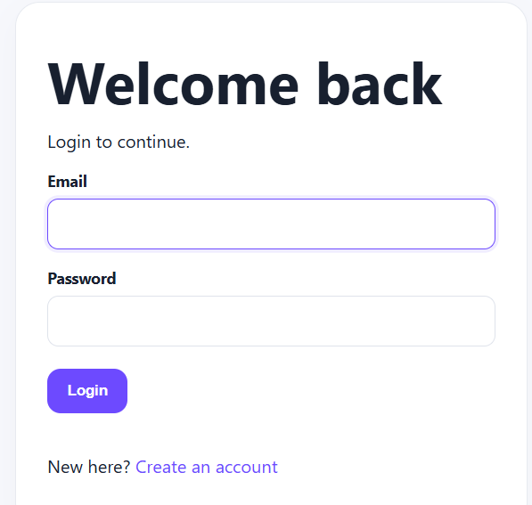
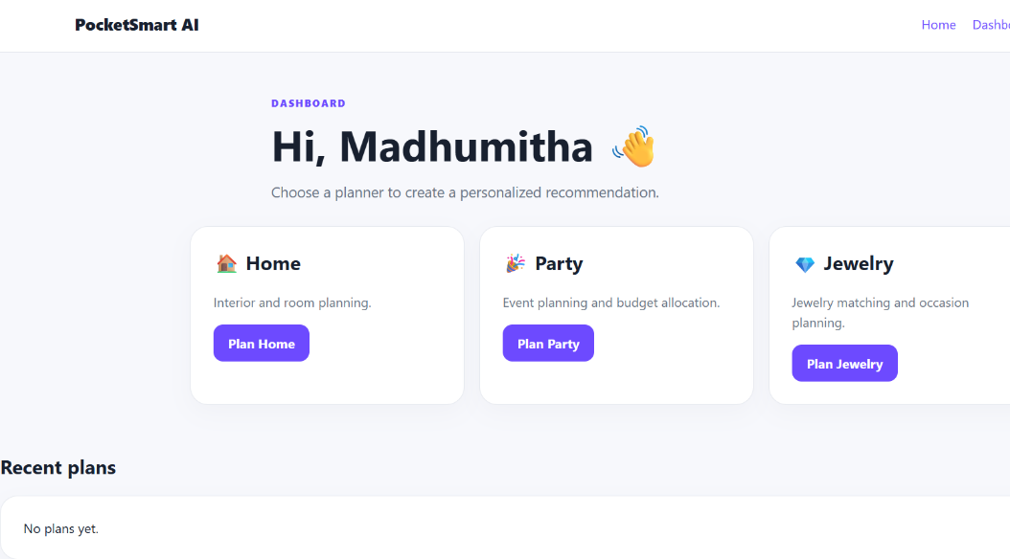
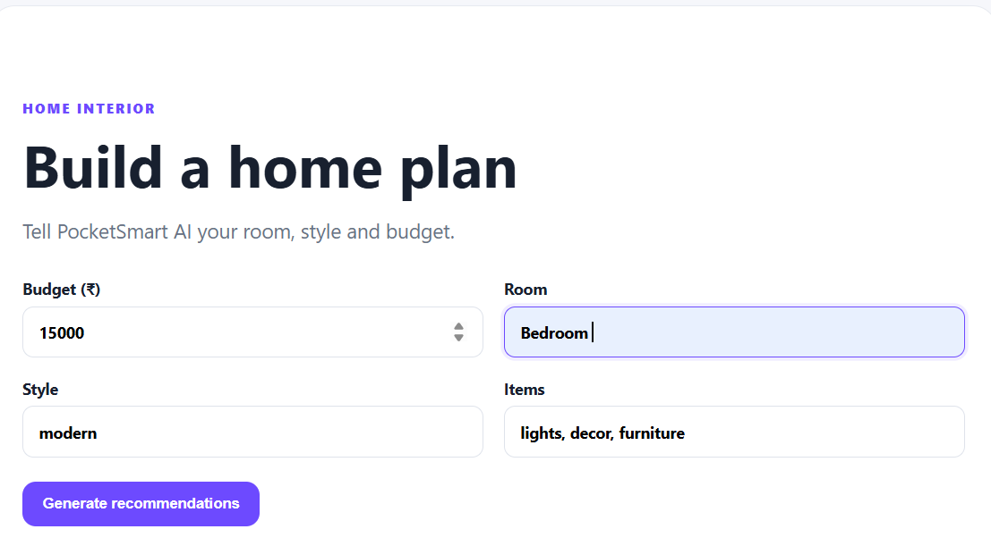
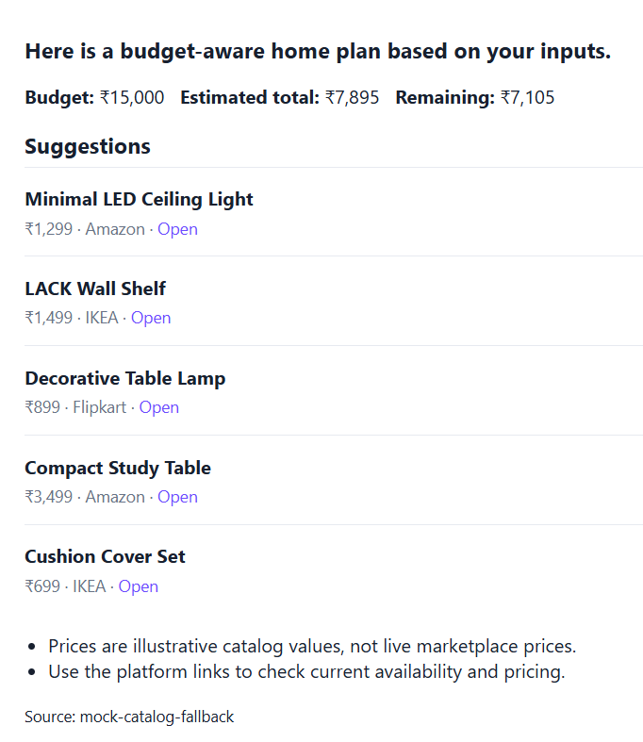

7.8 Database
SQLite is used for application data storage.
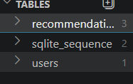

7.9 Implementation Summary
The application was implemented using a modular backend structure with FastAPI. The database manages required application information, while the frontend provides the user interaction layer.
The recommendation functionality processes the submitted user information and generates the corresponding result.

7.10 Testing Summary
The major functionalities of the application were tested, including authentication, dashboard access, budget input, recommendation generation, result display, and history functionality.

7.11 Challenges and Solutions

Challenge 1: Application Integration
Integrating the frontend with the backend required proper routing and request handling.
Solution: The application was organized using FastAPI routes and structured backend components.

Challenge 2: Database Integration
The application required persistent storage for user and recommendation-related information.
Solution: SQLite was integrated into the application for structured data storage.

Challenge 3: Recommendation Processing
The recommendation workflow required user inputs to be collected and processed correctly.
Solution: The application was designed to collect the required information before sending it to the recommendation processing component.

7.12 Benefits
The project provides:
- Simple budget-based interaction.
- Faster access to recommendations.
- Organized application workflow.
- Persistent recommendation information.
- User-friendly interface.
- Practical demonstration of AI-assisted recommendation technology.

7.13 Limitations
The recommendation quality depends on the quality and completeness of the information provided by the user and the capabilities of the implemented recommendation logic.
The application may also require further enhancement to support additional categories, platforms, and advanced recommendation capabilities.

7.14 Future Enhancements
Possible future enhancements include:
- Additional recommendation categories.
- More advanced personalization.
- Integration with additional product/service platforms.
- Improved recommendation ranking.
- Advanced analytics.
- Mobile application support.
- More advanced AI capabilities.
- Improved filtering and sorting options.

7.15 Conclusion
PocketSmart AI demonstrates how a web-based application can combine budget information, user requirements, backend processing, database storage, and intelligent recommendations into a single platform.
The project provides a practical approach to simplifying budget-based decision making and demonstrates the application of modern web development and AI-assisted recommendation concepts.
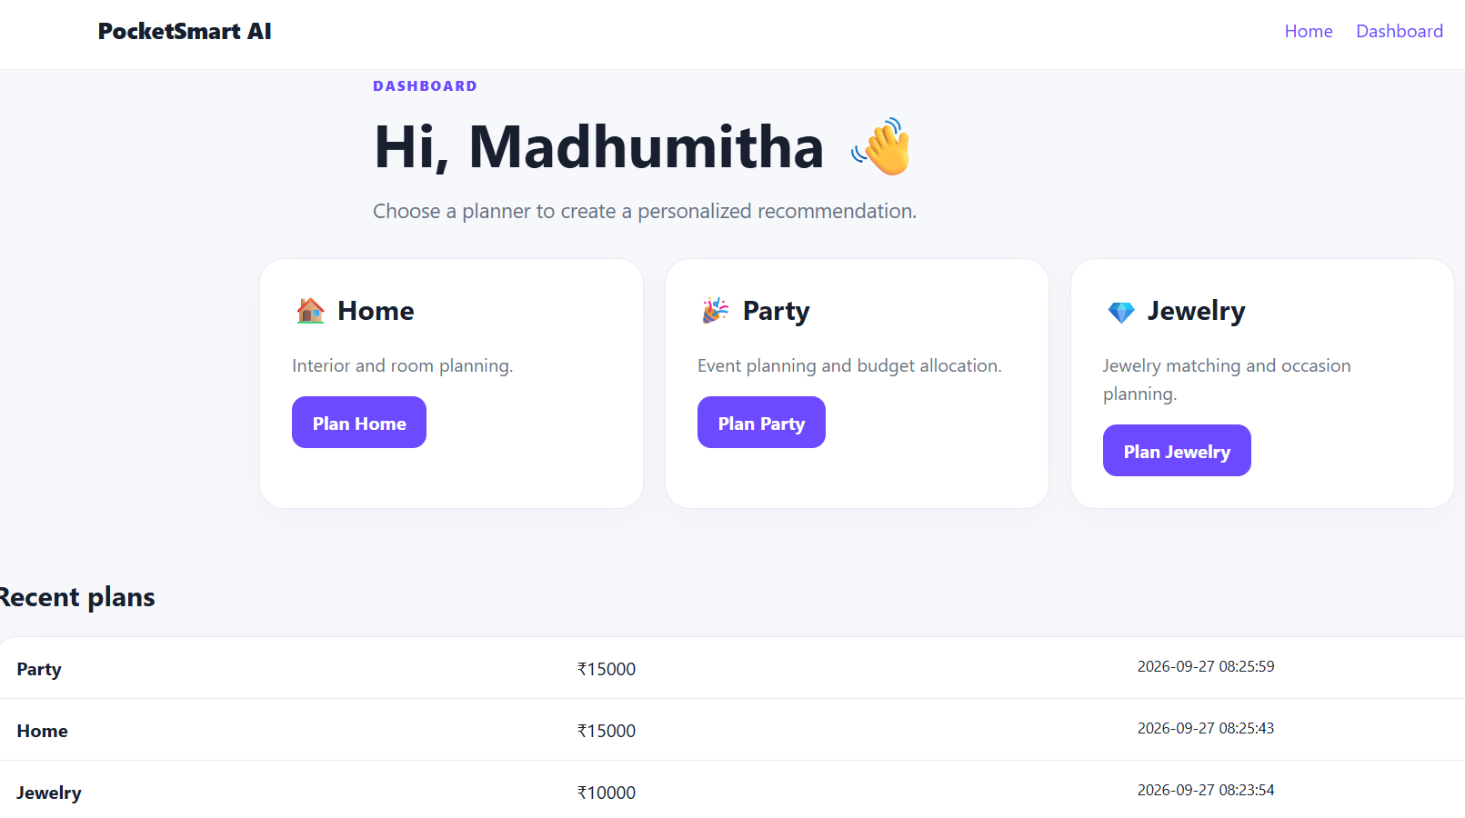

7.16 References
The project was developed with reference to the project document, project reference resources, and the technologies used during implementation.
- PocketSmart AI Project Document.
- SmartBridge Project Development Guidelines.
- FastAPI documentation.
- Python documentation.
- SQLite documentation.
- Project reference video provided by the training program.
- GitHub repository containing the project source code.

